http://www.megamanual.com/ms2/GM_7pinHEI.htm

The 7 Pin HEI Module

With a GM HEI 7-pin (and 8-pin modules), the ignition module wires you need to know about are:

* tach signal is a **purple** wire with a **white** trace [*pin R*]
* advance control signal is a **white** wire [*pin E*]
* override (cranking) signal is a **tan** wire with a **black** trace [*pin B*]
* ground is a **black** wire with a **red** trace [grounded to distributor case]

The 4-pin HEI uses a negative-to-positive transition, while the 7/8-pin uses a positive-to-negative transition (though this *\*might\** have changed in some applications). Thus polarity of the reluctor signal is critical to proper function.

In the GM 7/8-pin HEI, the module converts the AC signal from the variable reluctor pick-up {on *pins P & N*} in the distributor to a 'square wave' tach signal {on pin R} suitable for MegaSquirt-II. The falling edge of this square wave is used as the trigger event (which becomes the rising edge when the optoisolator inverts the signal).

HEI does not use the reluctor for dwell control, this is accomplished in the module. Dwell needs to be independent of RPM. Variable reluctor output is RPM dependent with regard to both its width and amplitude of its output. The only thing constant with a variable reluctor output is the location of the zero crossing point with respect to the passing tooth.

Be sure to get the variable reluctor pick-up wires connected properly. Reversing the variable reluctor sensor wires and thus the polarity of the sensor causes the leading voltage to go negative first and the electronics ignores the positive going transition. Thus trigger signal, if ever recognized, is the falling edge of the voltage as the end of the tooth passes.

The only way to get proper triggering at the center of the tooth is to have the positive Â½ cycle first (tooth approaching) and the negative Â½ cycle last.

The '**trigger offset**' in MegaTune is the number of degrees before TDC at which the VR sensor output goes from positive to negative, and the falling edge of the square wave is sent from the 7/8-pin module to MegaSquirt-II. This tells MegaSquirt-II where the crankshaft is positioned so that timing advance can be calculated appropriately. (Note that since the optoisolator (U4) inverts the trigger signal, you specify 'Rising edge' for the 'Input Capture' in MegaTune, which refers to the signal *at the processor*.) Positive trigger offsets are used to specify the number of degrees **before** top dead center (BTDC), negative numbers are used for triggers that occur after top dead center (ATDC).

The 7/8-pin HEI uses a "next cylinder" advance calculation method. That is, you get the square wave out of the module at (say) 10Â° BTDC which is used for cranking and limp home mode. To advance the timing MegaSquirt-II waits until the NEXT cylinder to fire to provided an altered signal to the coil.

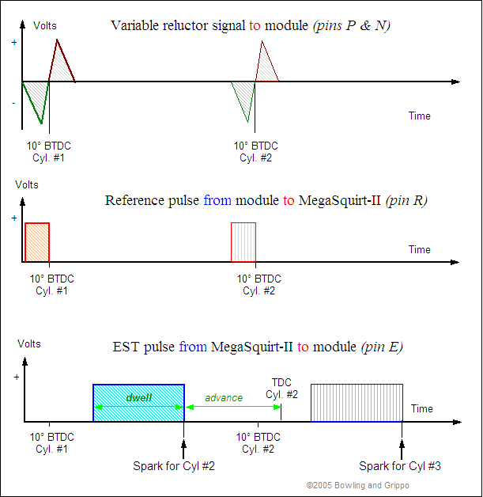

Reference (tach) pulses come into MegaSquirt-II from pin R at 10Â° BTDC (this offset can be calibrated using MegaTuneII so that the spark table values match the actual advance). At each reference pulse, the period between it and the previous reference pulse is calculated. The difference is used (with a time interpolation technique) to set up the timing pulse for the next ignition event. Specifically, the reference period is added to the time of the current pulse, a calculated amount subtracted for the advance, another amount subtracted for the dwell to determine the rise time.

To install the HEI with MegaSquirt-II, you connect:

**V2.2 main board:**

* the 5th hole of JP1 to the E pin on the HEI module (which you can jumper to an unused DB37 pin, if you want),
* the R pin on the HEI module to DB37 pin #24.

**V3.0 main board:**

* DB37 pin #**36** to the **E** pin on the HEI module
* DB37 pin #**24** to the **R** pin on the HEI module
* On the V3.0 main board:
  + use the 'Hall sensor circuit' (step #50 in the assembly guide),
  + jumper **OPTOIN** to **TACHSELECT** on the bottom side of the PCB, near the DB37 connector, opposite the heat sink,
  + jumper **TSEL** to **OPTOUT** on the bottom side of the PCB, near the center.
* jumper **JS10** to **IGN** (this uses the processor port for the outgoing timing signal directly),
* jumper **XG1** to **XG2** on the bottom side of the PCB, near the 40 pin socket,

*Note that some users have reported difficulties obtaining a clean trigger from HEI modules (often aftermarket modules rather than OEM General Motors modules). If you find this is the case in your install, check out the alternative trigger circuits here:*[*inputHEI.htm*](http://www.megamanual.com/ms2/inputHEI.htm)*.*

When the signal is 'high', current flows. When the signal is pulled low, current stops, the magnetic field in the coil collapses, and a spark is produced. Thus, the HEI module fires on the 'trailing edge' of the advance signal. The advance signal is generated by MegaSquirt-II from the tach signal by modifying its duty cycle (pulse width). Larger duty cycles mean less advance, as the spark is delayed by a larger amount.

The ignition signal going to MegaSquirt-II comes from pin **R** of the 7-pin HEI module and goes to the DB37 pin **24**, as usual.

The timing of the trailing edge determines the amount of advance: a longer pulse width means a more delayed, 'retarded' spark, while a shorter pulse width means an earlier 'advanced' spark.

In a GM vehicle, the override signal is zero volts during cranking (less than 400 rpm or 5 to 15 seconds), then there is 5 volts on this wire after the engine starts to signal the 7-pin module that it should use the signal on the white wire to control timing. You need to apply a 5 volt signal here in order to control the timing while running. A wire can be run from the 5 Vref for the TPS (Pin **26** on the DB37) to the HEI pin **B** through a relay that is switch from a source that is hot in RUN but not CRANK (see the diagram below). Most cars have a source like this, check your service manual.

Alternatively, you can use the [spare port settings](http://www.megamanual.com/ms2/spare.htm) to send a 5 Volt signal. The FIdle ports grounds the FIdle, so you'll need a pull up resistor to a 5V source (such as from the proto area).

To do this, you need to:

* solder one end of a 1K Ohm resistor into one of the 5V spots in the proto area. The pull up resistor can be any 1K Ohm resistor,
* then use a connecting wire ("jumper") from the other end of the resistor to the banded end of D8. Note that if you leave the resistor and jumper hanging, it might eventually break due to vibration. So you might want to solder jumper end the resistor into a empty hole on the proto area, then solder the jumper between the hole and the resistor body, which should secure it from vibration. Alternatively, you can glue it to the PCB at one or two spot with epoxy or hot glue.

Then set up the port conditions (rpm < 300) and settings (check these carefully), and you have the pin B signal on db37 pin #30.

So you are just applying 5V to one end of D8 through a resistor (and then setting the spare port settings of course!).

If you have the relay board, you can use the pull up on the relay board instead of in MegaSquirt. The FIdle relay might be set up to supply a ground or 12V depending on how it's jumpered. You want it to supply 5 Volts, and the way to do that is to remove the jumper and connect the center hole to Vref. (Check the [relay board schematics](http://www.bgsoflex.com/mspower/mspower_ShemV1.2.pdf).)

The FIdle is particularly useful, since most GM set-ups use a stepper, not the FIdle port. However you may already be using the FIdle output for a TCC (in which case you'll have to use one of the other ports like knock enable and add a transistor).

(Note that the 7-pin HEI module also has two pins for the variable reluctor pick-up ([*pin P*] and [*pin N*]) as well as one each for the coil [*pin C*] and +12 volts [*pin +*] from the battery. Together with the spark timing signal [pin E], Ref (tach) [pin R], and crank override [pin B], there are 7 pins in total ).

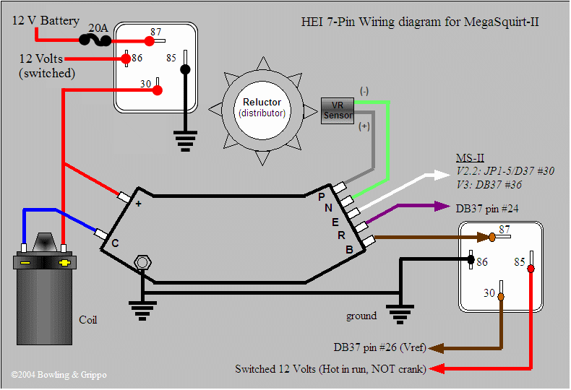   
*(Shown is the large 7-pin HEI module. The small 7-pin HEI module (used in Vauxhalls in the UK and is listed for the 1.6i Cavalier) is wired to the same pins, but the pins are grouped differently. P, N, E, R are on the right, +, C, and B are on the left)*

For using the HEI with a relay board:

* **Pin R** goes to **'tach'** on the 20-position terminal block (which in turn connects to DB37 #24).
* **Pin E** goes to **'S5'** on the 20-position terminal block (which in turn connects to DB37 #36).
* **Pin B** goes to dedicated wiring to a relay (as shown in the diagram), or to 'fidle' if you are using the [spare port settings](http://www.megamanual.com/ms2/spare.htm) and have modified the relay board's "GV" jumper to supply 5 Volts by connecting the middle terminal of the GV jumper to 'Vref' on the 20-position terminal block)
* **Pin C** goes to the coil's negative terminal,
* **Pin +** goes to the coil's positive terminal (and switched 12 V supply),
* **Pins P & N** go to the VR sensor.

Virtually any engine equipped with a variable reluctor distributor and a single coil can use the 7-pin HEI module to interface with MegaSquirt-II. These have the advantage of being cheap, widely available (in North America), and reliable. These are available as:

* Echlin **TP47** ~$70 at [NAPA OnLine](http://www.napaonline.com/)
* [Standard Motor Products](http://www.smpcorp.com/) **LX315**
* Accel **35363** ~$50 at [Summit](http://www.summitracing.com/)
* Holley **891-102** ~$27 at [Summit](http://www.summitracing.com/),
* General Motors **1976908**